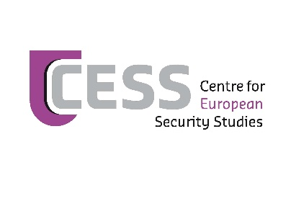

**EUCAM writing and outreach course**

The [Europe Central Asia Monitoring (EUCAM)](http://www.eucentralasia.eu/) initiative of the [Centre for European Security Studies (CESS)](http://www.cess.org/) is open to applications for its ‘civil society writing and outreach course’. This new 12-week online course will **start on 8 March and end on 4 June 2021**.

Selected participants will:

* Follow interactive classes from inspirational speakers and practitioners;
* Strengthen practical writing skills (policy papers, proposals, etc.);
* Improve public speaking skills (becoming a trainer, presentations, podcasts);
* Expand their network with European and Central Asian NGOers, think tankers, policymakers and donors.

The curriculum consists of 12 interactive sessions (one per week) and individual guidance in drafting an article. Upon completion of the course participants receive a certificate and a stipend of €300. Ideally participants would follow the course next to their obligations in Central Asian civil society (commitment of about 8 hours per week including contact hours).

We are looking for participants that:

* Are active in civil society and keen to improve their writing, outreach, training, and project development skills;
* Have a Kazakh, Kyrgyz, Tajik, Turkmen or Uzbek nationality and live in Central Asia;
* Have a good command of English.

You can apply by sending a motivation email and an attached one-page curriculum vitae *before* **Monday 8 February 2021** to [info@eucentralasia.eu](mailto:info@eucentralasia.eu). Eight candidates will be selected.

The EUCAM writing and outreach course is organised in cooperation with the [European Neighbourhood Council](http://www.encouncil.org/) (ENC). We thank the Open Society Foundations and the European Endowment for Democracy for their support.